Appendices (For Online Publication Only)

Appendix A: Additional Tables

Table A.1 Summary of Companion Research Papers

Paper | Research Question(s) | Main Finding(s) | Dataª
de Oliveira, Eckel and Croson (2011) | Is there a giving type? | Individuals who donate to one charity tend to donate to other charities. | Experimental and survey data
Leonard, T., R. T.A. Croson, and A. C.M. de Oliveira (2010) | Can charitable contributions and trust reported in the survey be explained by one’s connections in his/her social network? | The level of charitable contributions (reported in the survey) are associated with the size of one’s social network, but are not associated with the self-reported trust level. | Survey data only
de Oliveira, Eckel and Croson (2012) | Is cooperation stable with respect to contexts across multiple decisions in the field? | Decisions in lab VCM can serve as a good predictor for decisions in real donation games. | Experimental and survey data
Li, de Oliveira and Eckel (2015) ^{b} | Can identity priming, i.e., making one’s community identity salient, influence giving to local charities? | The impact of identity priming depends on participants’ perceived self-image of their neighborhoods. | Experimental and survey data
Note: ª The dataset used in the first three papers above were collected in neighborhoods 1 and/or 3. It contained primarily low-income African-American participants. Our dataset in this study included 26 observations (13 percent of the data) which were also reported in the non-identity-prime treatment in Li, de Oliveira and Eckel (2015).
^{b} While this paper and Li et al. (2015) both study identity, different methodologies are used. In this study the naturally-occurring social identity is elicited in the post-experimental survey. In contrast, Li et al. (2015) prime identity and make it salient for randomly selected participants through a pre-experimental questionnaire before any giving tasks. Then decisions are compared between those who receive the identity prime with those who do not.

Table A.2 Correlations between Contributions and Gambling/Time Preferences

Contribution ($) | Gambling Choice | Number of Patient Choices in the 10 Time Preference Tasks
VCM | 0.127 (0.072) | 0.190 (0.007)
Health | 0.114 (0.108) | 0.197 (0.005)
Education | 0.097 (0.172) | 0.279 (0.000)
Job Training | 0.181 (0.010) | 0.192 (0.006)
Notes: Correlations are reported with p-values included in the parentheses. In the gambling task, participants choose one from the six 50/50 gambles to play. They are coded as 1 for $80/$80, 2 for $60/$120, 3 for $40/$160, 4 for $20/$200, 5 for $0/$240, and 6 for -$20/$260. The ten time-preference choices include $64 tomorrow vs. $68 in one (or five) month; $60 tomorrow vs. $61 ($62, $64, $66, $68) in one month; $60 tomorrow vs. $65 ($70, $80, $90, $100) in five months.

Table A.3 Impact of Identity and Social Exclusion Factors on Giving
 | (1) | (2) | (3) | (4) | (5) | (6) | (7) | (8) | (9)
Dependent variable | Unconditional $ | Likelihood | Conditional $ | Unconditional $ | Likelihood | Conditional $ | Unconditional $ | Likelihood | Conditional $
Identity factor (β₁) | 2.656*** | 0.147*** | 4.034*** | 1.991** | 0.127*** | 3.272** | 2.527** | 0.145*** | 3.964**
 | (1.023) | (0.037) | (1.552) | (0.929) | (0.038) | (1.566) | (1.010) | (0.038) | (1.574)
Exclusion factor (β₂) | -0.275 | -0.041 | -0.291 | -0.015 | -0.035 | 0.081 | 0.131 | -0.026 | 0.283
 | (0.950) | (0.036) | (1.470) | (0.961) | (0.040) | (1.636) | (0.931) | (0.038) | (1.489)
Local (β₃) | -4.832*** | -0.112*** | -8.171*** | -4.421*** | -0.110*** | -8.204*** | -4.696*** | -0.115*** | -8.253***
 | (0.754) | (0.032) | (1.300) | (0.705) | (0.032) | (1.306) | (0.737) | (0.033) | (1.317)
Identity factor*Local (β₄) | -0.677 | -0.058 | -0.650 | -0.626 | -0.058 | -0.581 | -0.644 | -0.063* | -0.794
 | (0.963) | (0.036) | (1.530) | (0.881) | (0.035) | (1.531) | (0.937) | (0.037) | (1.548)
Exclusion factor*Local | -1.182 | -0.040 | -1.860 | -1.017 | -0.037 | -1.673 | -1.159 | -0.037 | -1.765
(β₅) | (0.968) | (0.037) | (1.519) | (0.876) | (0.037) | (1.492) | (0.939) | (0.038) | (1.528)
Overall effects on local organizations
Identity factor | 1.979** | 0.089*** | 3.384*** | 1.365** | 0.069** | 2.692** | 1.883** | 0.082** | 3.170**
(β₁ + β₄) | (0.769) | (0.032) | (1.245) | (0.677) | (0.031) | (1.215) | (0.797) | (0.035) | (1.372)
Exclusion factor | -1.457** | -0.082*** | -2.151** | -1.032 | -0.072** | -1.592 | -1.028 | -0.064** | -1.482
(β₂ + β₅) | (0.674) | (0.030) | (1.051) | (0.702) | (0.032) | (1.249) | (0.699) | (0.031) | (1.138)
Other covariates
Fractionalization | -29.477*** | -1.556*** | -51.198*** | -25.064*** | -1.570*** | -49.717***
 | (6.024) | (0.311) | (11.013) | (5.568) | (0.341) | (12.110)
Neighborhood median | 0.364*** | 0.016*** | 0.632*** | 0.252*** | 0.014*** | 0.522***
household income | (0.079) | (0.005) | (0.157) | (0.074) | (0.005) | (0.179)
Female | 1.846* | 0.083* | 2.554 |  |  |  | 1.648 | 0.074 | 2.181
 | (1.109) | (0.048) | (1.740) |  |  |  | (1.107) | (0.050) | (1.787)
Education | -1.519*** | -0.049** | -2.509*** |  |  |  | -1.495*** | -0.058*** | -2.533***
 | (0.518) | (0.022) | (0.844) |  |  |  | (0.505) | (0.023) | (0.845)
U.S.-born | -0.590 | -0.019 | -1.577 |  |  |  | -1.399 | -0.048 | -2.819
 | (1.710) | (0.071) | (2.737) |  |  |  | (1.676) | (0.075) | (2.784)
Only English spoken | -2.998 | -0.133* | -4.572 |  |  |  | -2.670 | -0.135* | -4.135
at home | (1.904) | (0.077) | (2.983) |  |  |  | (1.937) | (0.082) | (3.113)
Years living in | -0.002 | -0.002 | 0.011 |  |  |  | -0.022 | -0.003 | -0.012
community | (0.050) | (0.002) | (0.081) |  |  |  | (0.050) | (0.002) | (0.084)
No. of children | -1.270*** | -0.048*** | -1.933*** |  |  |  | 3.520*** | 0.098* | 6.385***
 | (0.416) | (0.017) | (0.682) |  |  |  | (1.255) | (0.058) | (2.056)
Income 10-20K | 3.839*** | 0.106* | 6.997*** |  |  |  | 3.086** | 0.083 | 5.196**
 | (1.260) | (0.054) | (1.995) |  |  |  | (1.400) | (0.066) | (2.388)
Income 20-30K | 3.309** | 0.086 | 5.536** |  |  |  | 4.002** | 0.178 | 7.632**
 | (1.334) | (0.059) | (2.166) |  |  |  | (2.015) | (0.115) | (3.625)
Income 30-40K | 3.768* | 0.145 | 7.077** |  |  |  | 0.550 | 0.053 | 2.152
 | (2.086) | (0.103) | (3.579) |  |  |  | (2.540) | (0.122) | (4.764)
Income > 40K | 1.699 | 0.095 | 4.348 |  |  |  | -0.982** | -0.033* | -1.537**
 | (2.530) | (0.117) | (4.628) |  |  |  | (0.431) | (0.019) | (0.739)
Risk | 0.734* | 0.053** | 1.231* |  |  |  | 0.558 | 0.045** | 0.953
 | (0.402) | (0.022) | (0.745) |  |  |  | (0.413) | (0.022) | (0.768)
No. of patient choices | 0.601*** | 0.024*** | 0.971*** |  |  |  | 0.617*** | 0.028*** | 1.060***
 | (0.163) | (0.008) | (0.291) |  |  |  | (0.168) | (0.009) | (0.303)
N | 804 | 804 | 804 | 804 | 804 | 804 | 804 | 804 | 804
Subjects | 201 | 201 | 201 | 201 | 201 | 201 | 201 | 201 | 201
Log likelihood | -2516.4 | -2577.5 |  | -2580.1 | -2652.5 |  | -2538.6 | -2611.0
Pseudo R² | 0.040 | 0.052 |  | 0.016 | 0.024 |  | 0.032 | 0.039
Note: This table is the same as Table 4 except that the average identity and social exclusion measures are replaced by the scores generated through the factor analysis. Tobit models are used in columns 1, 4 and 7. Cragg Hurdle models are used in columns 2-3, 5-6 and 8-9. We use the confirmatory factor analysis (with a varimax rotation) to generate a composite identity and a composite social exclusion factor. The identity (or social exclusion) items load on a single factor with an eigenvalue 1.85 (or 1.44). No other factor has an eigenvalue above 1, indicating that the identity and social exclusion items are common to a single composite factor, respectively. The correlations between the average measure (used in the main analysis) and the composite factor are 0.98 and 0.97 for identity and social exclusion. Marginal effects are reported. Standard errors clustered at the individual level are in parentheses. * p < 10%, ** p < 5%, and *** p < 1%.

Table A.4 Interaction Effect of Identity and Neighborhood Ethnic Fractionalization on Giving to Local Organizations
 | (1) | (2) | (3) | (4) | (5) | (6)
Dependent variable | Unconditional $ | Likelihood | Conditional $ | Unconditional $ | Likelihood | Conditional $
Identity | 5.105** | 0.359*** | 11.456*** | 5.269** | 0.466*** | 13.842***
 | (2.315) | (0.113) | (3.947) | (2.117) | (0.134) | (4.418)
Exclusion | -4.422** | -0.240** | -5.736* | -2.271 | -0.180* | -3.073
 | (2.228) | (0.095) | (3.133) | (2.294) | (0.103) | (3.688)
Fractionalization | -19.078 | -0.207 | -11.751 | -8.630 | 0.414 | 5.162
 | (15.346) | (0.737) | (24.788) | (15.251) | (0.849) | (28.117)
Identity*Fractionalization | -4.809 | -0.431** | -13.189** | -5.967 | -0.618*** | -17.333**
 | (4.005) | (0.190) | (6.524) | (3.793) | (0.215) | (7.234)
Neighborhood median | 0.391*** | 0.015*** | 0.585*** | 0.261*** | 0.013** | 0.456***
household income | (0.088) | (0.005) | (0.158) | (0.080) | (0.005) | (0.176)
Female | 3.036** | 0.104** | 3.951**
 | (1.271) | (0.052) | (1.808)
Education | -1.621*** | -0.054** | -2.433***
 | (0.591) | (0.024) | (0.857)
U.S.-born | -0.134 | 0.012 | -0.510
 | (2.060) | (0.081) | (3.056)
Only English spoken | -3.481 | -0.159* | -3.920
at home | (2.371) | (0.087) | (3.402)
Years living in | 0.002 | -0.001 | 0.021
community | (0.061) | (0.002) | (0.089)
No. of children | -1.561*** | -0.049** | -2.174***
 | (0.495) | (0.020) | (0.729)
Income 10-20K | 3.071** | 0.075 | 5.252**
 | (1.494) | (0.062) | (2.156)
Income 20-30K | 2.408 | 0.065 | 3.649*
 | (1.503) | (0.068) | (2.169)
Income 30-40K | 3.923* | 0.168 | 6.899*
 | (2.121) | (0.118) | (3.624)
Income > 40K | 2.409 | 0.098 | 5.437
 | (3.340) | (0.156) | (4.531)
Risk | 0.868* | 0.054** | 1.294*
 | (0.464) | (0.024) | (0.756)
No. of patient choices | 0.605*** | 0.020** | 0.840***
 | (0.200) | (0.010) | (0.310)
N | 603 | 603 | 603 | 603 | 603 | 603
Subjects | 201 | 201 | 201 | 201 | 201 | 201
Log likelihood | -1866.2 | -1830.3 |  | -1919.3 | -1887.7
Pseudo R² | 0.041 | 0.052 |  | 0.014 | 0.022
Note: We focus on the contributions to the local organizations in this table. Identity and the neighborhood ethnic fractionalization index is interacted. The set of the analyses is otherwise the same as columns 1-6 in Table 4. Tobit models are used in columns 1 and 4. Cragg Hurdle models are used in columns 2-3 and 5-6. Marginal effects are reported. Standard errors clustered at the individual level are in parentheses. * p < 10%, ** p < 5%, and *** p < 1%.

Appendix B: Experimental Instructions and Forms

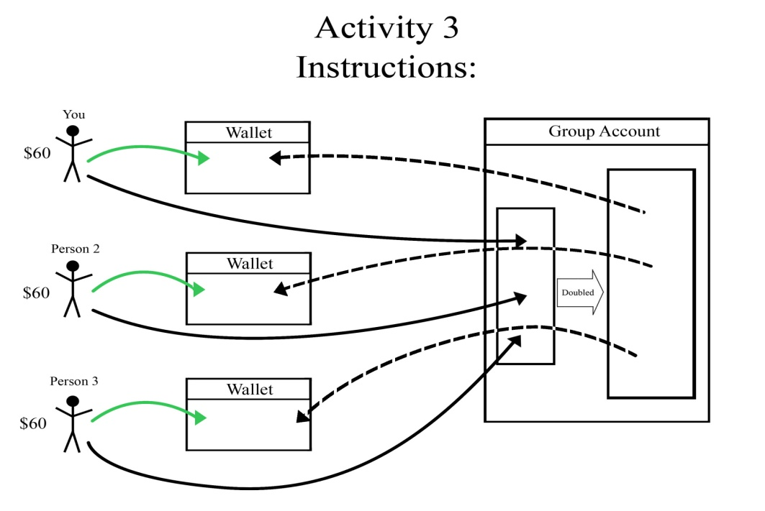
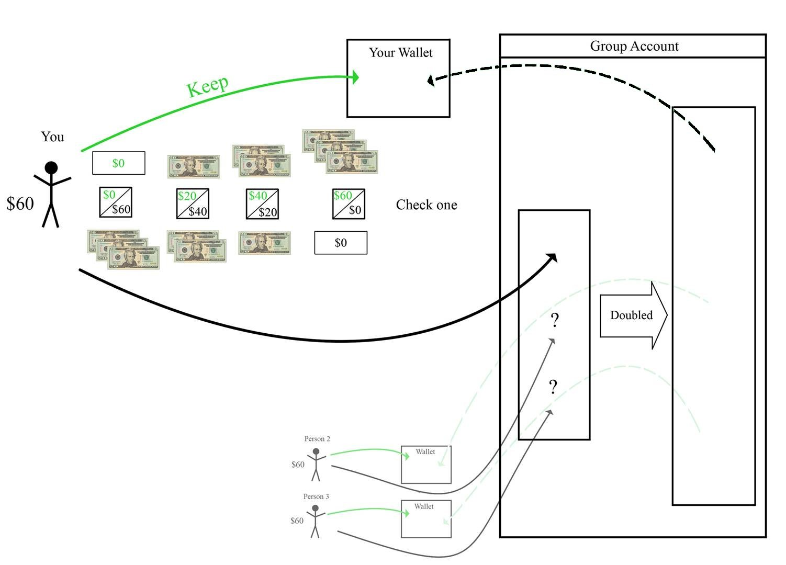
Fig. B.1 Lab VCM
Notes: This pictorial design of experimental instructions was tailored for the low-literacy population in our study. It was accompanied by an oral script in Spanish: “You are in a group of three people; the other two people are in the room. But you won’t know who they are and they won’t know who you are. Each person has $60. Each person decides how much to put in their wallet and how much to put in the group account. The money in the group account is doubled and then divided evenly among the three group members.” In the decision form (the second figure above), participants select one of four options by checking off one box on the decision form. In each box the number on the top left shows the amount one can keep; the number on the bottom right shows the amount to be sent to the group account.
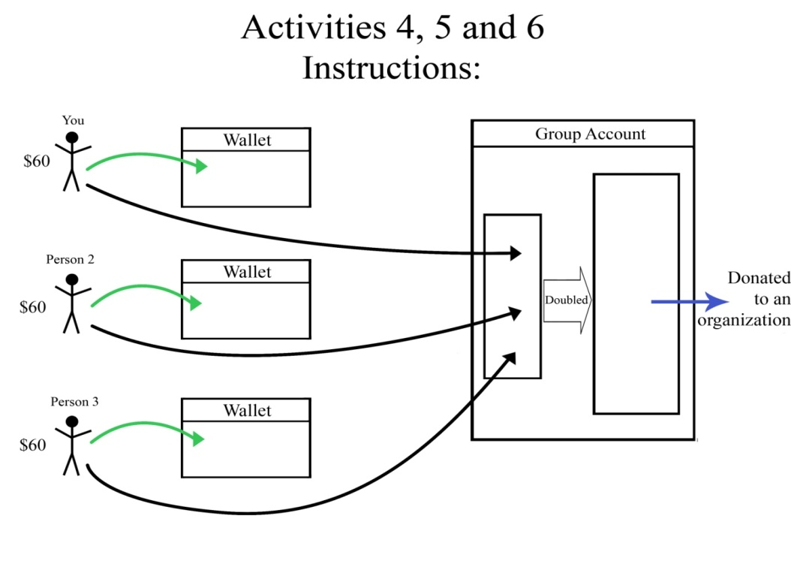

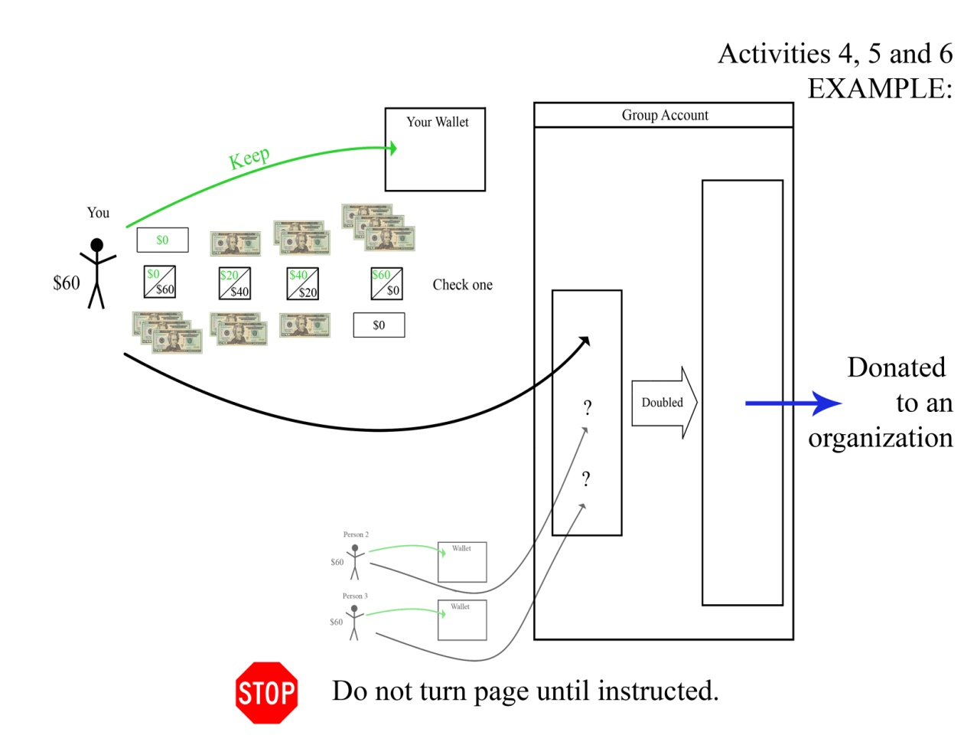
Fig. B.2 Real Donation Tasks to Local Organizations
Notes: The oral script to accompany the pictorial instruction was: “You are in a group of three people; the other two people are in the room. But you won’t know who they are and they won’t know who you are. Each person has $60. Each person decides how much to put in their wallet and how much to put in the group account. The money in the group account is doubled and contributed to an organization that provides education/job training/health services in your neighborhood.” In the decision form, participants select one of four options by checking off one box on the decision form. In each box the number on the top left shows the amount one can keep; the number on the bottom right shows the amount to be contributed.

Appendix C: Post-Experimental Survey Questions on Identity and Social Exclusion

Identity (The five identity measures are bolded below. They were not bolded in the post-experimental survey that was conducted.)
I. People have different views about themselves and how they relate to the world. How strongly do you agree or disagree with each of the following statements about how you see yourself? (1=strongly disagree, 4=strongly agree)

- I see myself as an American.
- I see myself as a Texan.
- I see myself as a member of my neighborhood.

II. In the (neighborhood name) area, people come from many different places. However, you have all chosen to live in the (neighborhood name) neighborhood. As members of the same neighborhood, you share many public facilities, for example, parks, schools, public libraries, museums, roads, public transportation, local stores, and many others. These questions are about how strongly you identify with being a resident of the (neighborhood name) area.

Please indicate how much you, as a resident of the (neighborhood name) area, agree or disagree with each of the following statements. (1=strongly disagree, 2=disagree, 3=neutral, 4=agree, 5=strongly agree)

A. I have spent time trying to know more about the history and traditions of the (neighborhood name) area.
B. I am active in organizations or social groups that include mostly residents of the (neighborhood name) area.
C. I think a lot about how my life is affected by living in the (neighborhood name) area.
D. I am happy that I am a resident of the (neighborhood name) area.
E. I have a strong sense of belonging to the (neighborhood name) area.
F. In order to learn more about the (neighborhood name) area, I have often talked to other people about it.
G. I have a lot of pride in the (neighborhood name) area.
H. I participate in neighborhood activities with other members of the (neighborhood name) area.
I. I feel good about living in the (neighborhood name) area.

Social Exclusion
Are there any of the following activities that you want to participate in, but you can’t? Check ALL that apply.

- Having a bank account
- Saving for retirement
- Having a cooperative account among friends, coworkers, etc.
- Participating in political issues or belong to a political organization
- Voting
- Working
- Going to school
- Owning a home
- Having health insurance
- Getting a loan

